# CMS TEXTS GUIDE:

## HOW TO ACCESS TO THE CMS OF CAFFE.COM?

ADMIN SITE: <https://admin.pt.caffe.com/>

CREDENTIALS:

|  |  |
| --- | --- |
| USERNAME | PASSWORD |
| User1 | Pwd1 |
| User2 | Pwd2 |

## HOW TO CHANGE SOME TEXTS?

After Login you’ll see the homepage of the CMS, the “**Orders summary**”.

At the left of your screen there is a navigation bar rendered in vertically that allow you to change the module you are working on.

In this little guide the scope is to introduce you to make sure you understand the basics of How to do changes about site texts.

To manage the translations and texts you need to open the tab “**Translations**” like in the picture below:

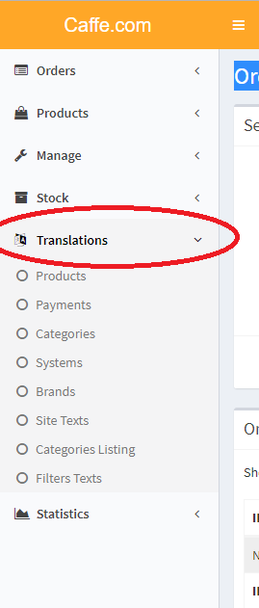

It will show you some options, to modify the common site texts you need to go into “**Site Texts**” section:

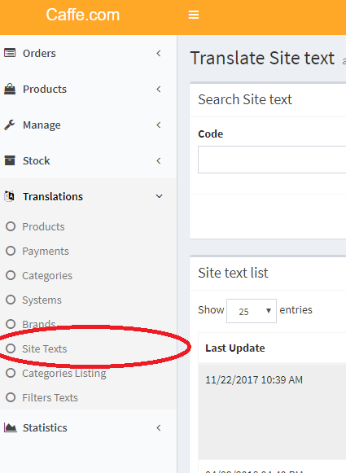

In the module “**Site Texts**” you can search by code, description (this means the text that is shown in the site) anche by language, in this particular case Português.

The thing that i suggest you is to open your caffe.com site in you browser: <https://pt.caffe.com> and copy a piece of the text you want to edit, you can search the text in the admin using the field “description”.

Just a little example:

Copying the text: 

And searching it on the admin :

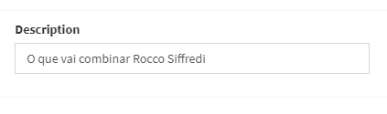

It will display you the text:

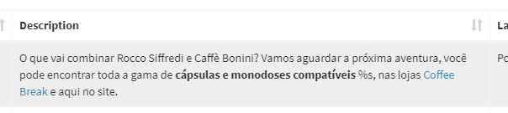

So you can edit this text just by using the button: 

REMEMBER: if you find in a text the character “**%s**” don’t delete it or modify because it’s a variable.

## HOW TO UPLOAD TEXT CHANGES TO THE SITE?

Caffe.com has a cache system that make’s everything faster and increase speed loading of pages.

All the changes that you can make are loaded by executing automations that have the job to refresh texts, images, prices exc..

This kind if auotmations are executed in an automatic way so you don’t need to worry about that, in case you want to upload now all tha changes you did to the texts you can start the automation called “**REFRESH TEXT SITE CACHE**” using your CMS!

To do that you need to change module from “**Translations**” -> “**Site Texts**” to the new “**Manage**” -> “**Cache Site**” like in the picture below:

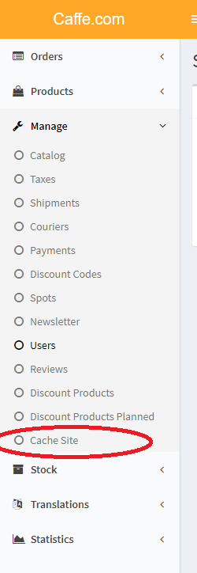

At this point you can choose what automation start, in this case you can execute **REFRESH TEXT SITE CACHE**



After that i suggest you to execute the automation **REFRESH SITE CACHE** too, just to make sure everything reloads properly.